***Ahsanullah University of Science & Technology***

Department of Computer Science & Engineering



HOTEL MANAGEMENT SYSTEM

CSE 3224

Information System Design

&

Software Engineering

Md.Junaeid Hossain 16.01.04.118

Afranul Haque 16.01.04.059

Nazmus Sakib 16.01.04.072

Md.Ruhul Amin 16.01.04.074

**Introduction:**

* Here we described the ERD means Entity Relationship Diagram which represents the data modeling tools.
* By using this ERD model we can easily understand the relationship between the entity of our database.
* Hotel management system is mainly a desktop based application. This project will be developed to maintain a hotel in a digitalized way.
* Our main goal is to digitalize the analog system. Hopefully it will be able to reduce times and troubles of administrators of a hotel.

**Name of Entities with primary,foreign and composite Keys:**

* ENTITIES:
* Receptionist
* Customer
* Room
* Food
* Manager
* Employee

**ENTITY RELATIONSHIP DIAGRAM:**

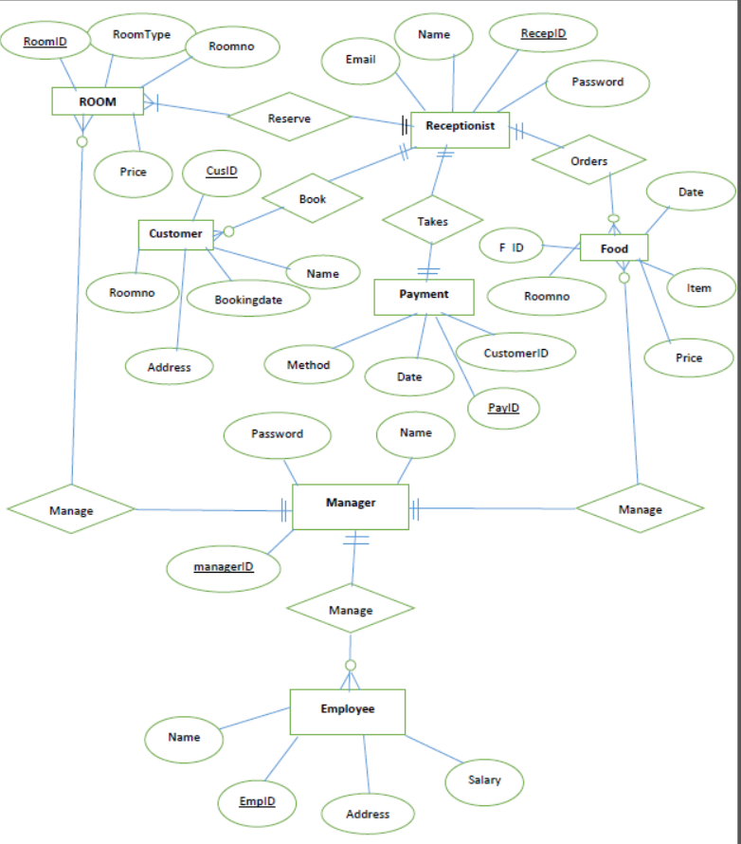

**RELATIONAL MODEL:**

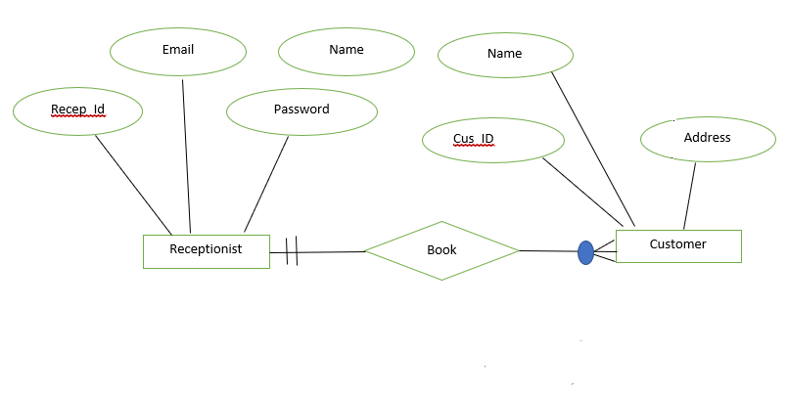

Create table Receptionist{

RecepID INT;

Receptionist_Name Varchar;

Receptionist_Email varchar;

Password varchar ;

PRIMARY KEY(RecepID)

};

Create table Customer{

Cus_ID INT;

Customer_name Varchar;

Customer_address varchar;

…

PRIMARY KEY(Cus_ID)

};

Create table Booking{

Customer_ID INT;

Room_No INT;

Booking_date Varchar;

deposit double;

…

PRIMARY KEY(Customer_ID)

FOREIGN KEY (Room_no) REFERENCES Room(Room_no);

};

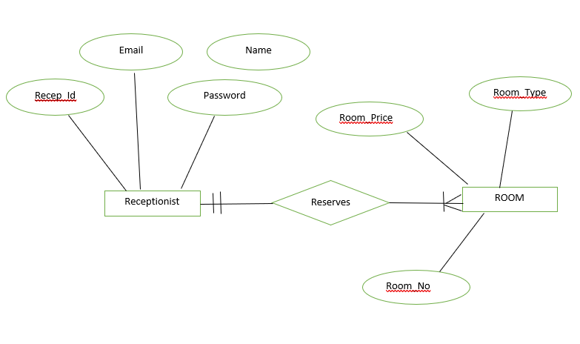

Create table Room{

Room_no INT;

Room_type Varchar;

Price Double;

…

PRIMARY KEY(Room_no)

};

Create table CheckIN{

Cus_ID INT;

Room_no INT;

date varchar;

…

PRIMARY KEY(Room_no)

};

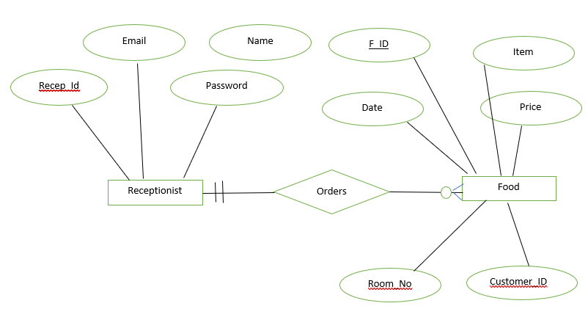

Create table Food{

FooD_ID INT;

Food_item Varchar;

Food_price double;

…

PRIMARY KEY(Food_ID)

};

Create table Manager{

Manager_ID INT;

Manager_name Varchar;

Password varchar;

…

PRIMARY KEY(Manager_ID)

};

Create table Employee{

Emp_ID INT;

Employee_name Varchar;

salary varchar;

Emp_Address varchar;

…

PRIMARY KEY(Emp_ID)

};

**Converting the generic SQL script to tables we have the following:**

Receptionist

|  |  |  |  |
| --- | --- | --- | --- |
| RecepID (PK) | Receptionist_Name | Receptionist_Email | Password |
|  |  |  |  |

Customer

|  |  |  |
| --- | --- | --- |
| Cus_ID (PK) | Customer_Name | Customer_Address |
|  |  |  |

Booking

|  |  |  |  |
| --- | --- | --- | --- |
| Customer_ID (PK) | Room_No (FK) | Booking_Date | deposit |
|  |  |  |  |

Room

|  |  |  |
| --- | --- | --- |
| Room_No (FK) | Room_Type | Price |
|  |  |  |

CheckIN

|  |  |  |
| --- | --- | --- |
| Cus_id | Room_no(PK) | date |
|  |  |  |

Food

|  |  |  |
| --- | --- | --- |
| Food_ID (PK) | Food_item | Food_price |
|  |  |  |

Manager

|  |  |  |
| --- | --- | --- |
| Manager_ID (PK) | Manager_name | Password |
|  |  |  |

Employee

|  |  |  |  |
| --- | --- | --- | --- |
| Emp_ID (PK) | Employee_name | salary | Emp_Address |
|  |  |  |  |

**Conclusion:**

ER Diagram

Entity Relationship Diagrams are a major data modeling tool.Analyst can produce a good database structure so that the data can be stored and retrieved in a most efficient manner.By using a graphical format it may help communication about the design between the designer and the user and the designer and the people who will implement it.

February 18, 2019

2